Problem-2:
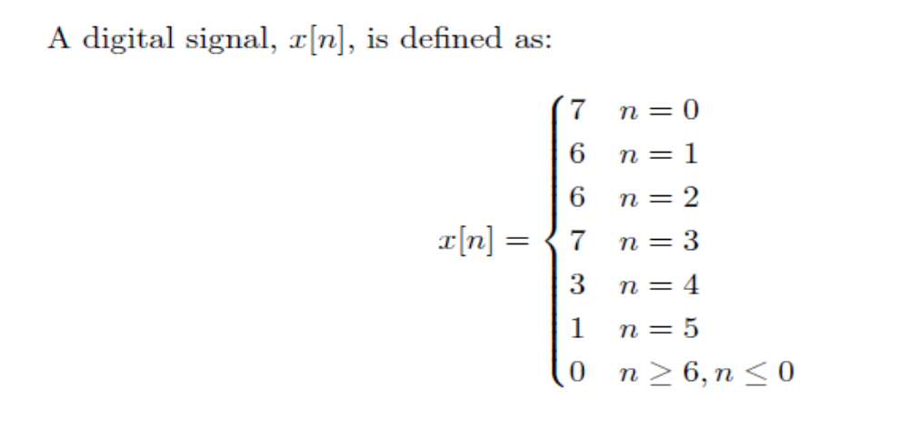
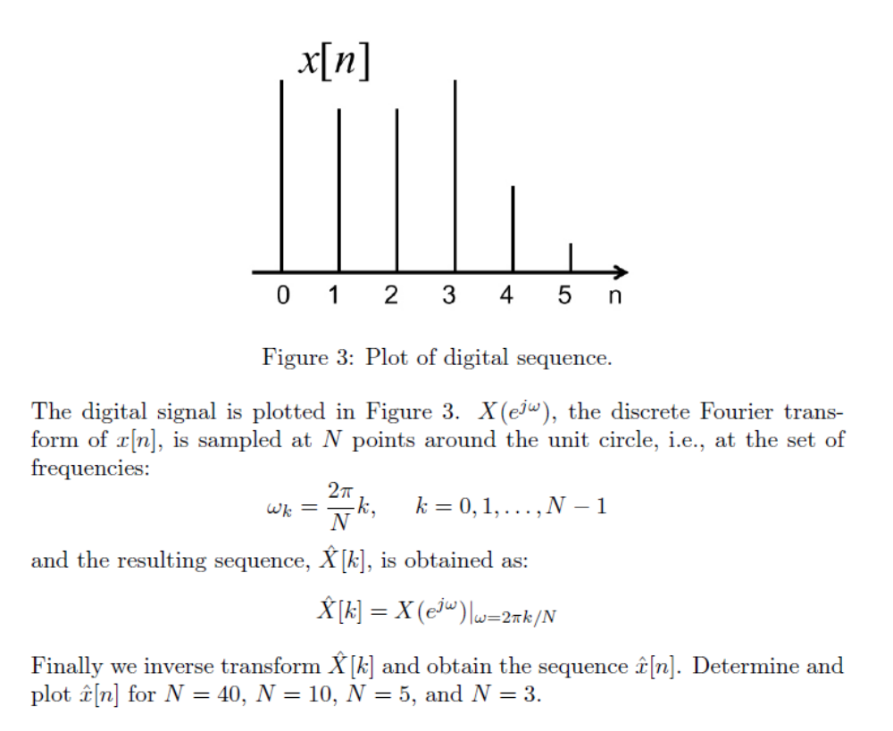
When we sample the discrete Fourier transform of the sequence at N points around the unit circle, we alias the original sequence around the N-th point.
Hence, if N is greater than or equal to the length of the original sequence, there is no aliasing and the sequence corresponding to the sampled discrete Fourier transform is the same as the original sequence.

This is the case (no aliasing) for N = 40 and for N = 10.
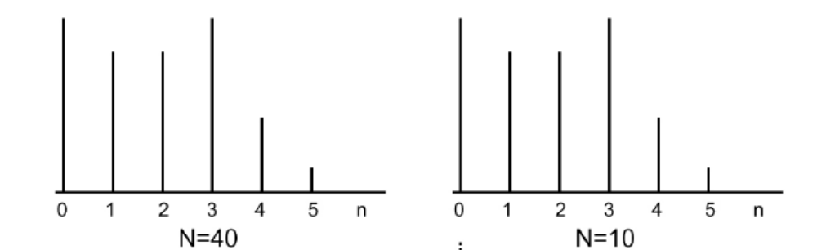
For N = 5 and N = 3 the signal alias the original sequence around the 5th point (for N = 5) and around the 3rd point (for N = 3)
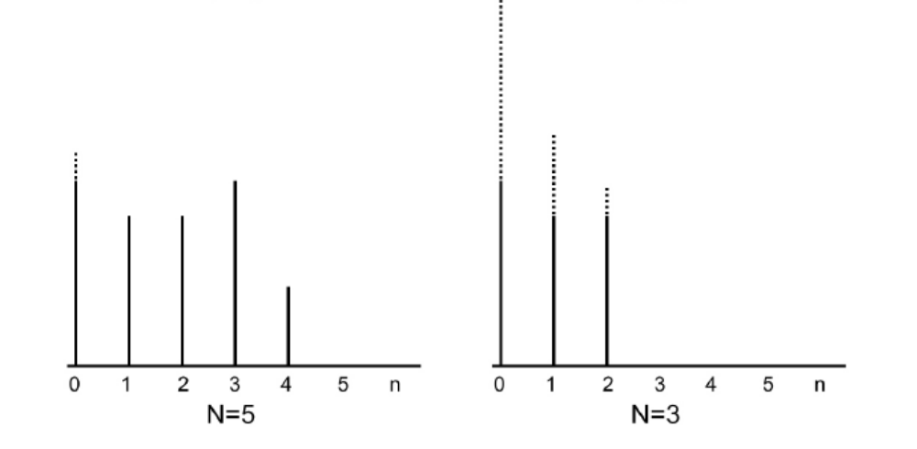

Problem 3:

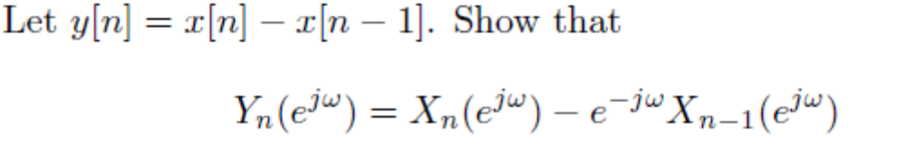

Solution:

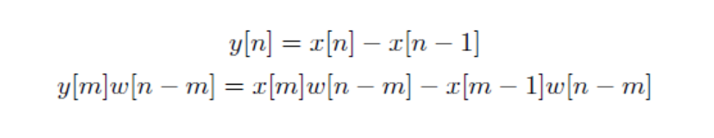
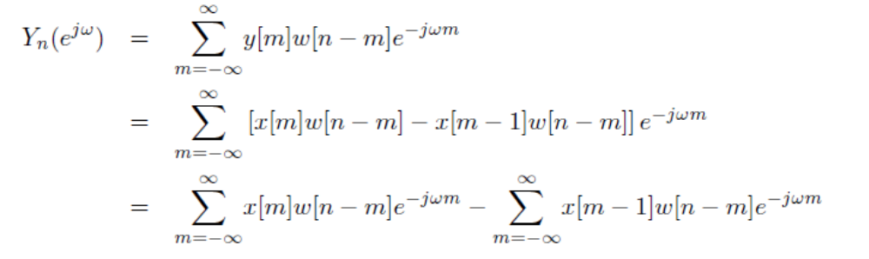
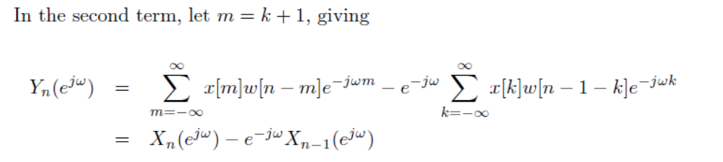

Problem 4:

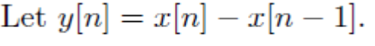
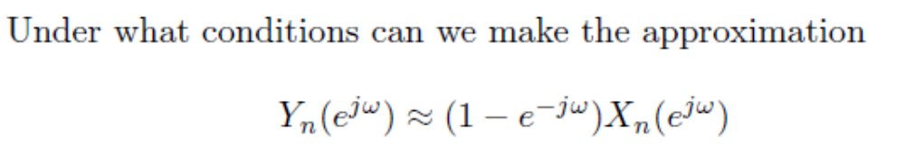

Problem 5:

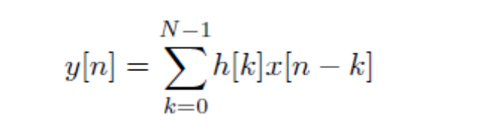
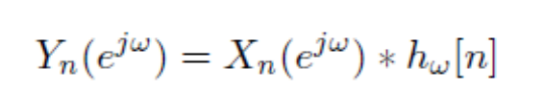

Solution:

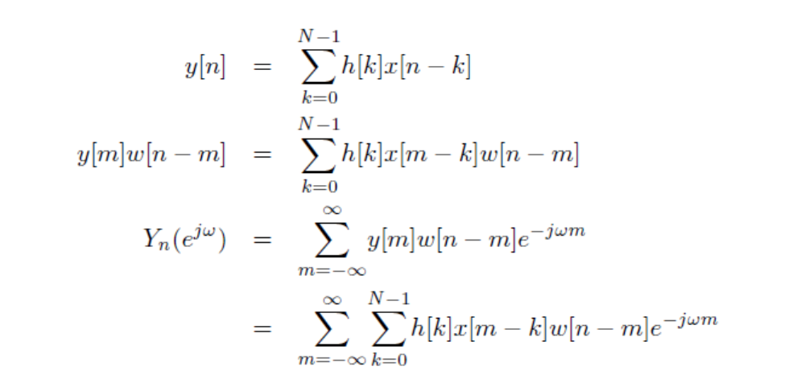
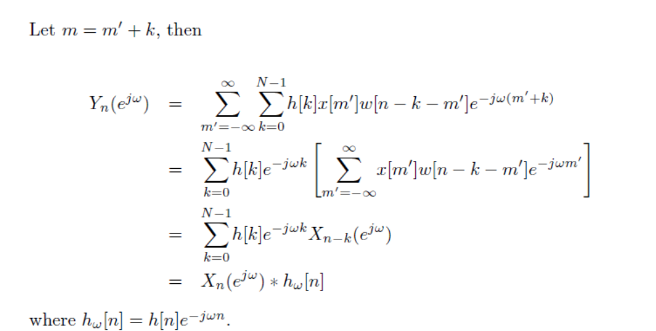

Problem 5:
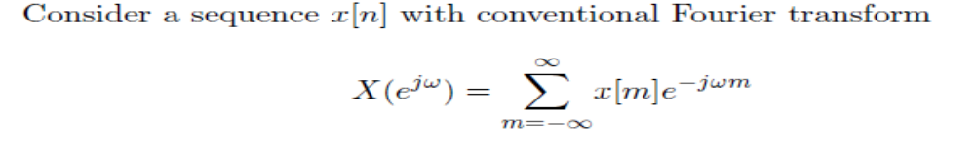
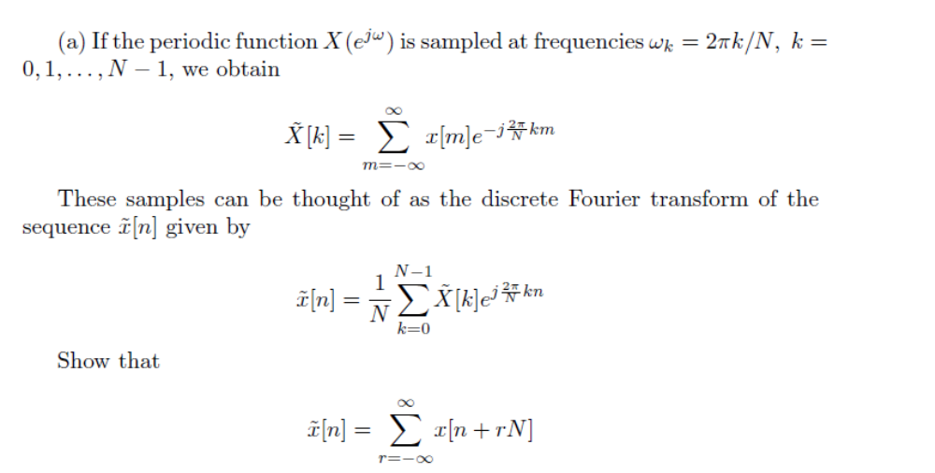

Solution:
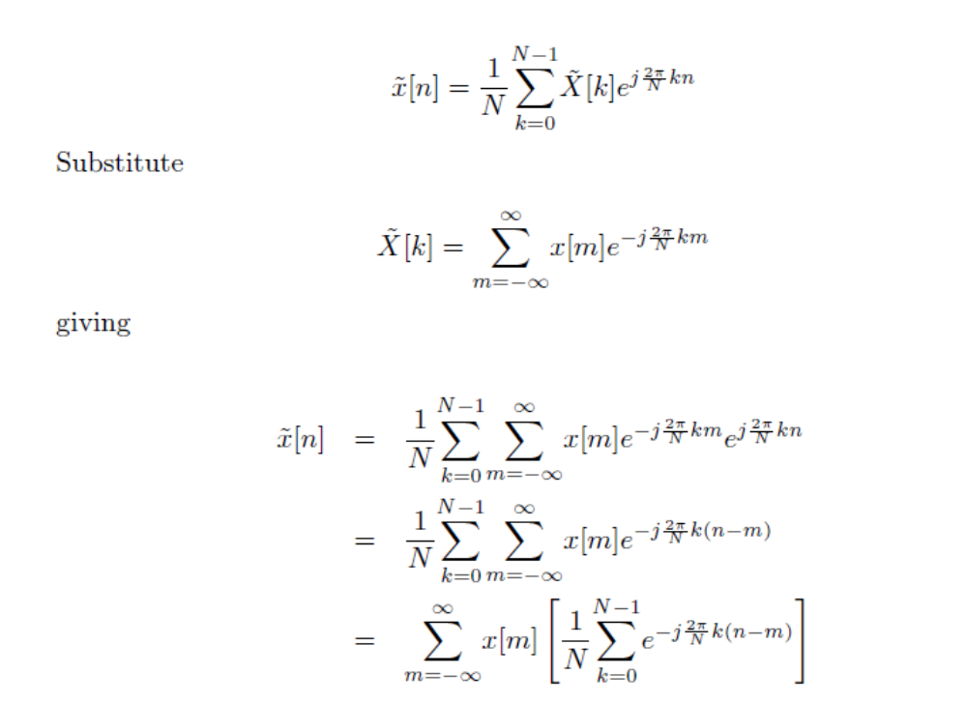
now
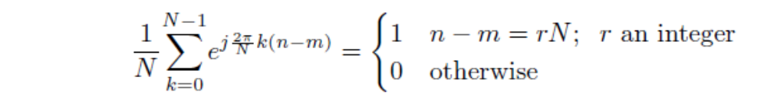
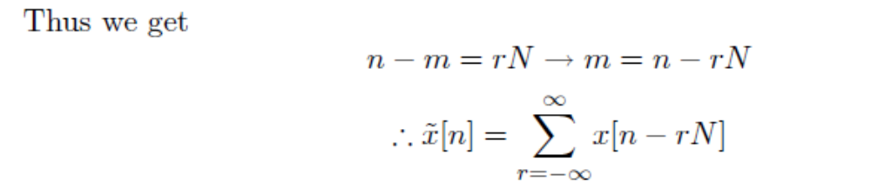

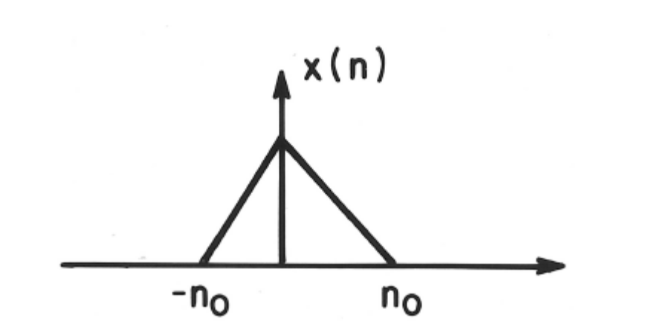
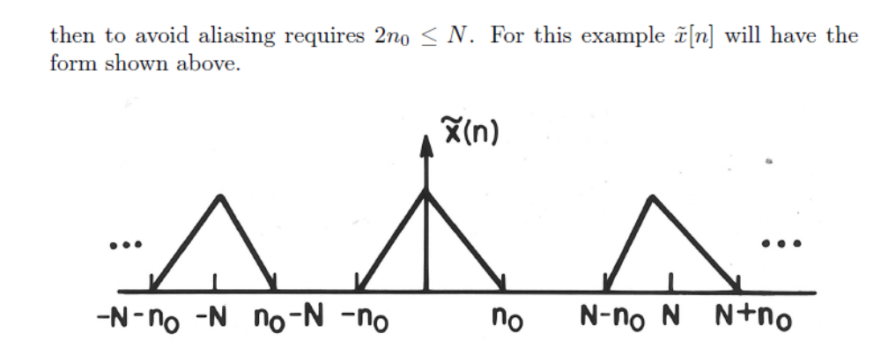

Problem 6:
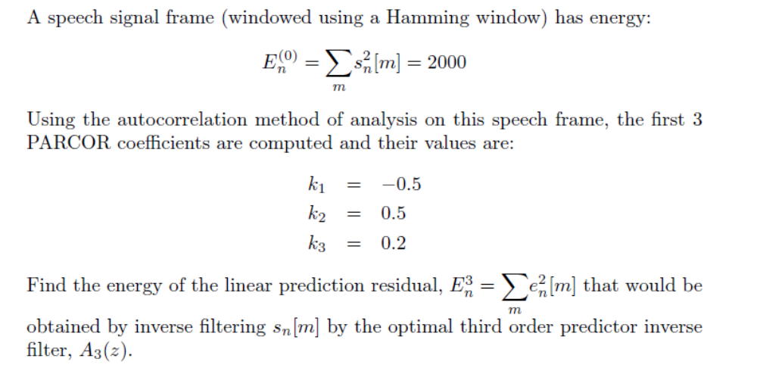
Solution:
